# 例子: 一个AP跨两个时间段需要两次计算

餐厅编号: 1400065 合同编号:132.000003 AP会计周期: 20090101-20091231

## 规则信息:

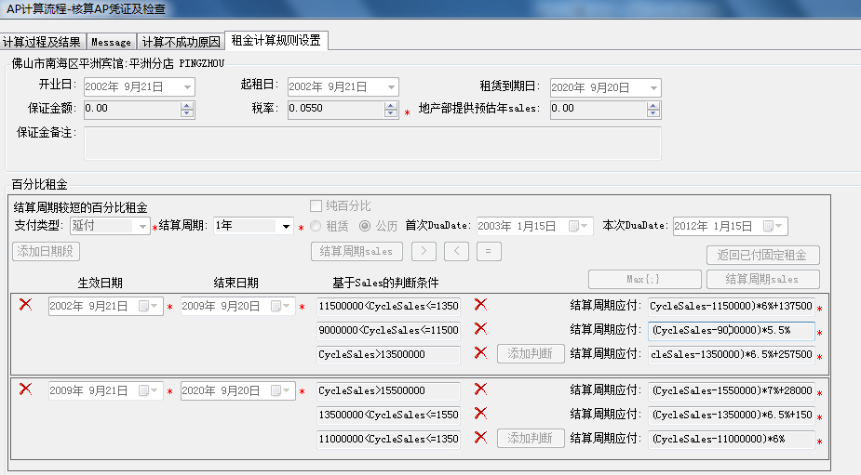

原条件公式:

|  |  |  |
| --- | --- | --- |
| 时间段 | 条件 | 公式 |
| 20090101-20090920 | 9000000<CycleSales<=11500000 | (CycleSales-9000000)*5.5% |
| 11500000<CycleSales<=13500000 | (CycleSales-1150000)*6%+137500 |
| CycleSales>13500000 | (CycleSales-1350000)*6.5%+257500 |
| 20090921-20091231 | CycleSales>15500000 | (CycleSales-1550000)*7%+280000 |
| 13500000<CycleSales<=15500000 | (CycleSales-1350000)*6.5%+150000 |
| 11000000<CycleSales<=13500000 | (CycleSales-11000000)*6% |

20090101-20091231SALES: 16957360.36

## 系统计算过程:

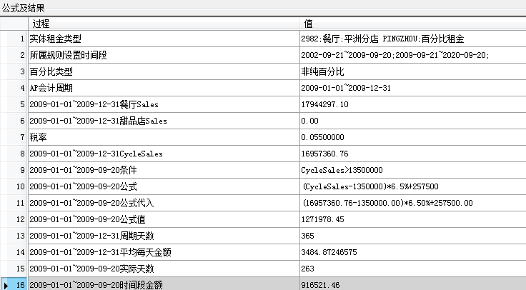

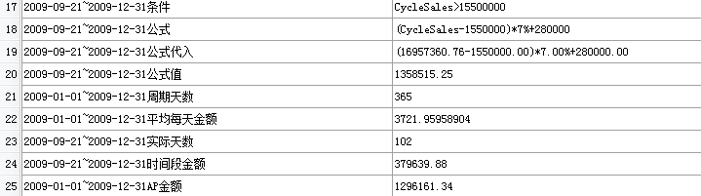

## 手工计算过程:

假设:

20090101-20091231SALES: 16957360.36

|  |  |  |
| --- | --- | --- |
| 20090101-20090920时间段SALES | 10000000 | 263天 |
| 20090921-20091231时间段SALES | 6957360.36 | 102天 |

先折算条件:

|  |  |  |  |
| --- | --- | --- | --- |
| 20090101-20090920时间段条件点 | 9000000 | 11500000 | 13500000 |
| 按X/365*263折算 | 6484923 | 8286290.5 | 9727384.5 |
| 20090921-20091231时间段条件点 | 11000000 | 13500000 | 15500000 |
| 按X/365*102折算 | 3073972 | 3772602 | 4331506 |

原条件公式:

|  |  |  |
| --- | --- | --- |
| 时间段 | 条件 | 公式 |
| 20090101-20090920 | 9000000<CycleSales<=11500000 | (CycleSales-9000000)*5.5% |
| 11500000<CycleSales<=13500000 | (CycleSales-1150000)*6%+137500 |
| CycleSales>13500000 | (CycleSales-1350000)*6.5%+257500 |
| 20090921-20091231 | CycleSales>15500000 | (CycleSales-1550000)*7%+280000 |
| 13500000<CycleSales<=15500000 | (CycleSales-1350000)*6.5%+150000 |
| 11000000<CycleSales<=13500000 | (CycleSales-11000000)*6% |

按折算SALES 20090101-20090920取条件公式: 10000000>9727384.5

按折算SALES 20090921-20091231取条件公式: 6957360.36>4331506

|  |  |  |
| --- | --- | --- |
| 时间段 | 条件 | 公式 |
| 20090101-20090920 | CycleSales>13500000 | (CycleSales-1350000)*6.5%+257500 |
| 20090921-20091231 | CycleSales>15500000 | (CycleSales-1550000)*7%+280000 |

手工计算:

|  |  |  |
| --- | --- | --- |
| 时间段 | 手工计算方法 | 值 |
| 20090101-20090920 | (10000000-9727384.5) *6.5%+(9727384.5-8286290.5)*6%+(8286290.5-6484923)*5.5% | 203260.86 |
| 20090921-20091231 | (6957360.36-4331506)*7%+(4331506-3772602)*6.5%+(3772602-3073972)*6% | 262056.36 |

# 例子: 时间段前不够一个周期

# 例子: 时间段后不够一个周期

# 例子: 发起AP后,AP不是所有GL都发起,导出凭证问题